Berry Landcare

Berry Wildlife Corridor Environmental Trust Bush Connect grant:
Previous Landcare articles have introduced to the readers the “NSW Great Eastern Ranges” corridor project and the “Berry Wildlife Corridor” This corridor identifies the connection between “Barren Grounds Nature Reserve” and “Seven Mile Beach National Park”. Berry Landcare applied for and has received a grant of $500,000 from NSW Environmental Trust under its “Bush Connect” program. This funding is to be applied to work associated with the corridor over the next six to ten years.
This money will in part fund environmental work on sites that fall within the area of the corridor. Such work could include weed eradication, revegetation of degraded forest or bushland, fencing for protection of existing areas of native flora and fauna identification and protection. The area of the corridor is mostly private land and accordingly the work will require the consent and co-operation of the land owners. Berry Landcare hopes to identify those sites where owners are willing to commit to such programs. The funding will require the active co-operation of landholders and will be supported by the Berry Landcare. Any land owners interested in being involved should contact the co-ordinator of the “Berry Corridor Working Group”, Bill Pigott - 44643241 or wpigott@bigpond.net.au.

Weed and Native of Month:
Sweet Pittosporum: This is a local native plant that has become naturalised in and around urban areas due to the imbalance of its natural habitat. A small to medium tree with dense dark green foliage and bunches scented creamy flowers. Fruit 10mm dia maturing green to orange. Seeds are spread by birds. Control is easy, by removal of young trees by hand. This tree can be useful to initiate canopy shade to control regrowing pasture.
Rough Fruiting Pittosporum: A handsome rounded shrub 3 m high. Foliage elliptical form to 10mm with new leaves brown dusty appearance. Noted for its bright red fruit in yellow kernels.

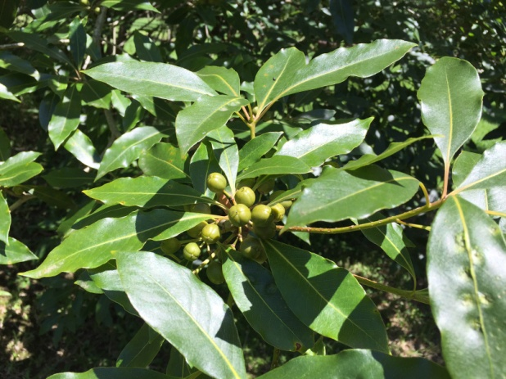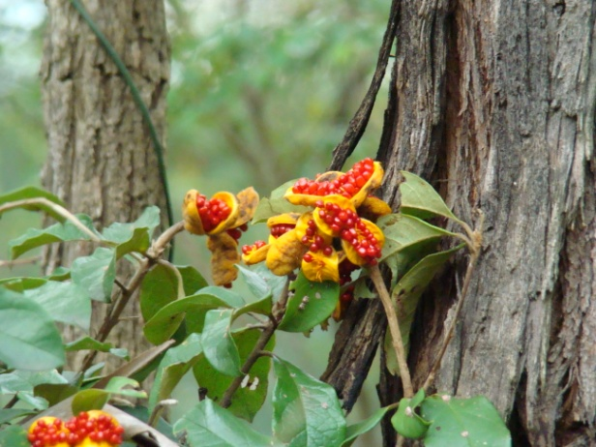
Sweet Pittosporum Rough Fruiting Pittosporum

Working Bees for February 2016:
Alexandra Street Parkcare: 9-11 am Friday 19th February: Gail Paton 44487915.
Bong Bong Road: 9-11am Sunday 14th February: Julia Woinarski 4464 2084.
Broughton Vale: 3-5 pm Sunday 7th February: Barry Virtue 44641389
Bundewallah Bushcare: 3-5pm Sunday 28th February: John Clark 44643911.
Camp Quality: 9-11am Sunday 21st February: Jeanne Highland 4464 1271.
Moeyan Hill: 3-5pm Saturday 20th February: Bill Pigott 44643241 or wpigott@bigpond.net.au.
Mount Coolangatta: 1-3 pm Saturday 20th February at end of Roxbrough Rd, Far Meadow.
Be on time to get a lift to site: Myke Cunningham 0418 297 435 or mcunningham@pci.cx.
Mark Radium Park: 9-10am Friday 19th February: Rodney Cole 4464 1475.
Princess Street Park: 10am Tuesday 23rd February: Terry Oades 44643651.
Tindalls Lane: 3-5 pm Sunday 14th February: Harvey Blue 4464 1880 or Jim Jefferis 4464 2988.
Information can also be found at Berry Landcare on Facebook.
Plant identification service: Please contact Harvey Blue 4464 1880 or Ian Parker, 4448 6359.
Visit our pages at: http://www.landcare.nsw.gov.au/groups/berry-landcare for more on Berry Landcare and late changes to working bee details. Information can also be found on Facebook.

